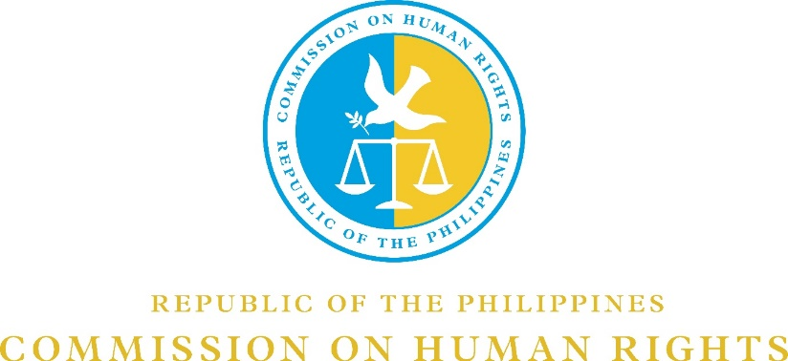

CHR V ON-THE-SPOT ESSAY WRITING CONTEST 2020

On the 48th year anniversary of the declaration of Martial Law in the Philippines, the Commission on Human Rights Region V is sponsoring a virtual essay writing contest to bring the lessons of Martial Law to the Filipino youth.

Contest Rules and Mechanics:

- The contest is open to all college students in Bicol region.

- Essay should be written in English, encoded, double spaced in a 12-font size Times New Roman.

- Contents should be a minimum of 1,500 words and a maximum of 2,000 words.

- Participants shall provide the following personal details in a separate page or sheet of paper, viz:

Name
Age
School
School Identification Card (ID)

- The contest shall start at 8:00 AM on 18 September 2020, and end at 12:00 NN on the same day via Google Meet (meet.google.com/hmd-tmxj-dnp). Entries shall be submitted online to the e-mail addresses of Geneva J. Avila (genevajavila@yahoo.com) of the Panel of Judges:

Dr. Ma. Rosario B. Cesario (cbcesario@firstasia.edu.ph)
Arch. Tessa C. Espinas-Salinas (architect.tessa@gmail.com)
John Joseph J. Perez (totepperez@yahoo.com)

- Criteria for Judging:

CRITERIA | DESCRIPTION | PERCENTAGE
Content | Substance, Relevance of the Topic, Accuracy of Data | 50%
Organization | Unity and Clarity of Thought | 25%
Form & Style | Originality & Creativity | 15%
Mechanics | Grammar & Punctuation | 10%
TOTAL |  | 100%

- The decision of the judges shall be final.

- The winners will receive a Cash Prize and a Certificate of Recognition. All participants will be given a Certificate of Participation.

Best Essay – P6,000.00
1st Runner Up – P5,000.00
2nd Runner Up – P4,000.00

- The Awarding of Winners will be on 21 September 2020 at 5:00 PM via Google Meet (meet.google.com/pze-wapo-tgy).

- For inquiries, you may contact Ms. Geneva J. Avila (09155208192) or Ms. Mary Janice B. Ceneta (09175002238).

