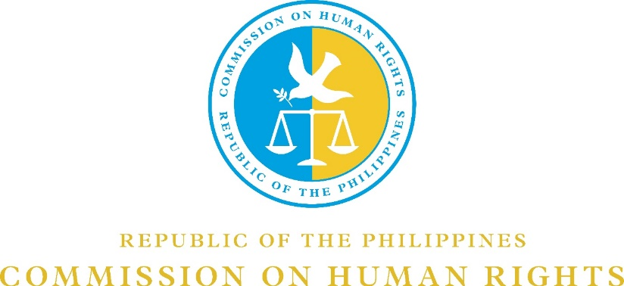

CHR V ONLINE BLACK AND WHITE PHOTOGRAPHY COMPETITION 2020

On the 48th year anniversary of the declaration of Martial Law in the Philippines, the Commission on Human Rights Region V is sponsoring an online black and white photography competition to bring the lessons of Martial Law to the Filipino youth.

To join, please take note of the following mechanics:

- The contest is open to all college students in Bicol region.

- The submitted photograph shall be the original work created solely of the entrant.

- The photograph must depict the theme: “The Philippines: Forty-Eight Years After Martial Law”.

- The photograph must not contain obscene, provocative, defamatory, sexually explicit, or otherwise objectionable or inappropriate content.

- Entries should be submitted online on or before 17 September 2020 to the e-mail addresses of Geneva J. Avila (genevajavila@yahoo.com) and the Panel of Judges:

Dr. Ma. Rosario B. Cesario (cbcesario@firstasia.edu.ph)
Arch. Tessa C. Espinas-Salinas (architect.tessa@gmail.com)
John Joseph J. Perez (totepperez@yahoo.com)

- Entries will be judged on the basis of creativity (40%), effectiveness in expressing the contest theme (35%), and photographic quality (25%).

- Participants shall provide the following personal details in a separate page or sheet of paper, viz:

Name
Age
School
School Identification Card (ID).
A brief analysis of the photograph submitted

- The decision of the judges shall be final.

- The winners will receive a Cash Prize and a Certificate of Recognition. All participants will be given a Certificate of Participation.

Best Black and White Photograph – P6,000.00
1st Runner Up – P5,000.00
2nd Runner Up – P4,000.00

- The Awarding of Winners will be on 21 September 2020 at 5:00 PM via Google Meet (meet.google.com/pze-wapo-tgy).

- For your inquiries, you may contact Ms. Geneva J. Avila at this number: 09155208192.

